Multi-purpose lock instruction booklet
I. product characteristics:
1, working style: It locks when the power is off and opens quickly when it is electrified with (12v). It can be used in all kinds of intelligent signal attachments.
2, specification size: It is as small as a name card(95mm*56mm),13mm thick and it weights about 180g.
3, urgent unlocking: There are three ways to unlocking it in urgengtly situations, and it is also equipped with mechanical lock function.
4, energy saving: It needs only less than 1second to electrify when it unlocks. It does not need electricity when it is locked(voltage12V, electric current 1A )
5, material saving: The ultra-thin design saves raw material so that it provides larger and more flexible arrangement space for the cabinet.
6, long life: The aging test 6000000 time can guarantee that the coil does not burn down.
7, Status Output: There are signals about the lock’s states, which is used to detect the door’s working state(open or closed).
8, public use: It has no positive and reverse side design and the lock can be used in all cases, cabinets and drawers from different directions, which realize the funtions of Multi-purpose lock.
9, ways of installing: It can be fixed outside the cabinet directly. Embedded and hidden installation are also possible.
10, security: It is anti-vibration and against picking locks. It can also be used in finance , military and so on.
Ⅱ, instruction of usages and installation
1, Users should read this instruction booklet carefully to check if the major assemblies are included before use. First connect the devices once according to the electric circuit wiring diagram before installing(simulation). Install it again after the multi-purpose lock work normally.
2, The multi-purpose lock mainly consists of the hook and lock(the main body). Please adjust their moderation while installing. Being smooth and flexible is the best condition.
3, There are five wires stretching out in the multi-purpose lock's rear part :red, black, blue, white, the yellow(their places can be changed with each other), the red and black wire or the two red wires are the lock’s electric source wire. And there is no need to tell the positive and negative poles. Blue, white and yellow wires are used to detect the state of the door. The blue color means it is normally open (NO), the white means the common point (COM), and the yellow means it is normally closed (NC); When the door opens, the close point separates, open point puts through; After the door closes absolutely, the state of the two points can interchange automatically.
4, The product uses the mechanical delay technology. It can lock automatically when the door closes. The user can use mechanical and electric lock to open the door separately(get in touch with the seller before ordering).
5, there are 3 ways to unlock when urgently



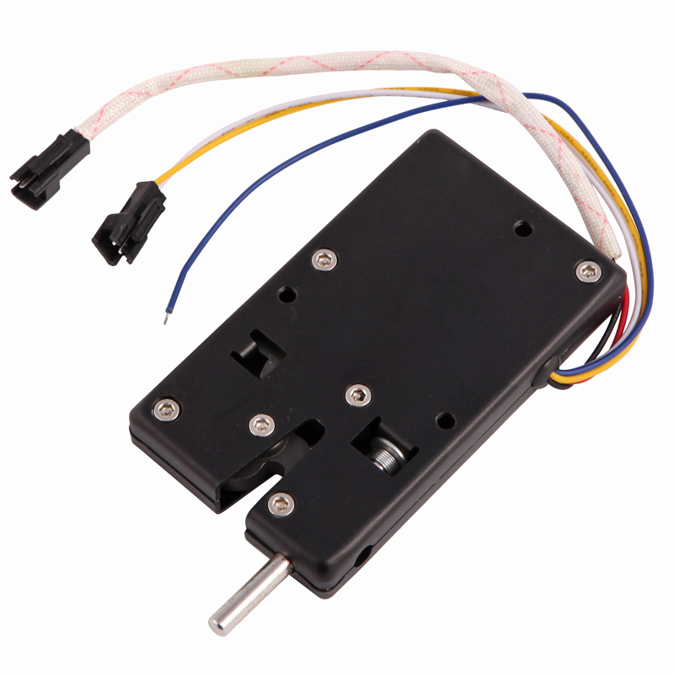
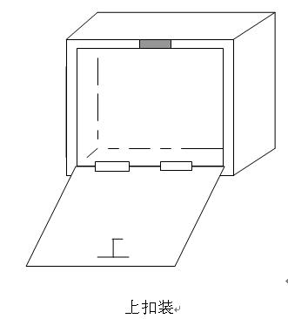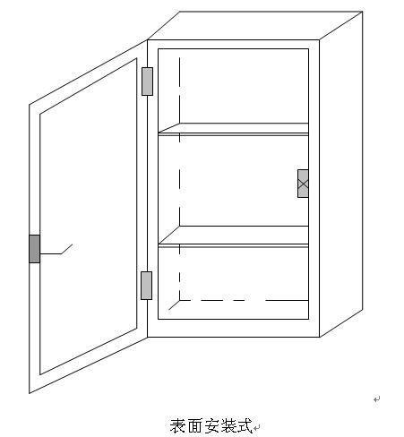
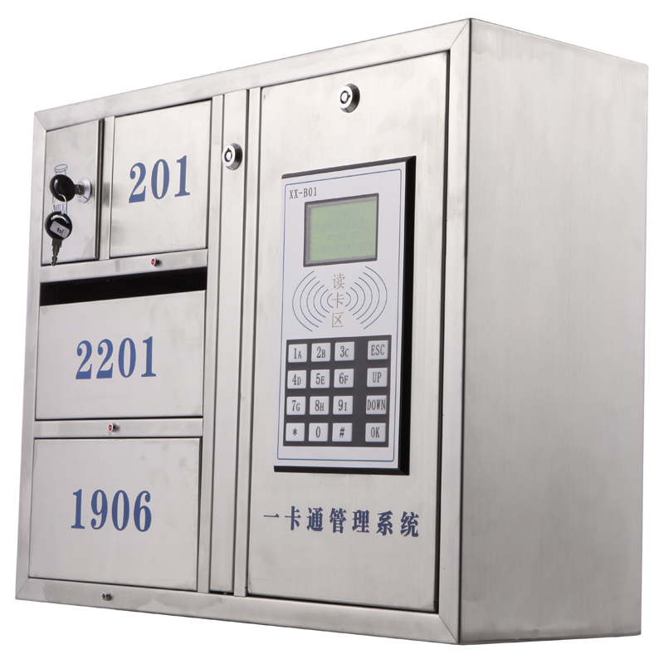
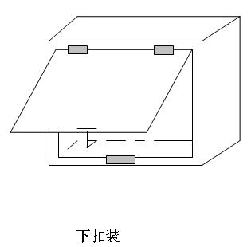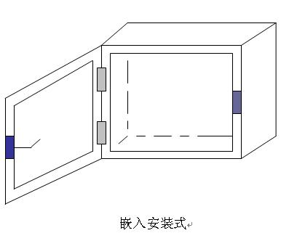
Ⅲ, application scopes
It can be used in drawers, the letter or newspaper boxes, the cabinets for checks, the filing cabinets, the book cabinets, the electric instrument boxes, the cabinets for storing articles, the cabinets to change clothes in ......Widely applies in places such as schools, mines, factories, banks, armies, jails, courts, hotels, farms, bath centers.

Warning: This product is protected by patent law. Illegal copy will be prosecuted and will beat the legal consequences! Anyone who reports to the authorities can get the prize. The highest reward is 100,000 Yuan! Telephone:0086 755-29960565 13823599162

